# LTC (Long Term Care)

The current structure is as follows:

The main package here is called Main.dtsx and it calls various sub packages per client. These can be easily copied for new clients but there IS a Lookup in each script that should be modified to ensure the correct PMDClientID is matched up to.

The package is located here: G:\artifacts\prod\com.pharmmd.etl.LT

The process is currently set to expect a certain number of contracts per client. This is configured within the package in an array fashion.

This sub ETL process follows the Session->Raw->Spec process of loading and progressing data from file to the database.

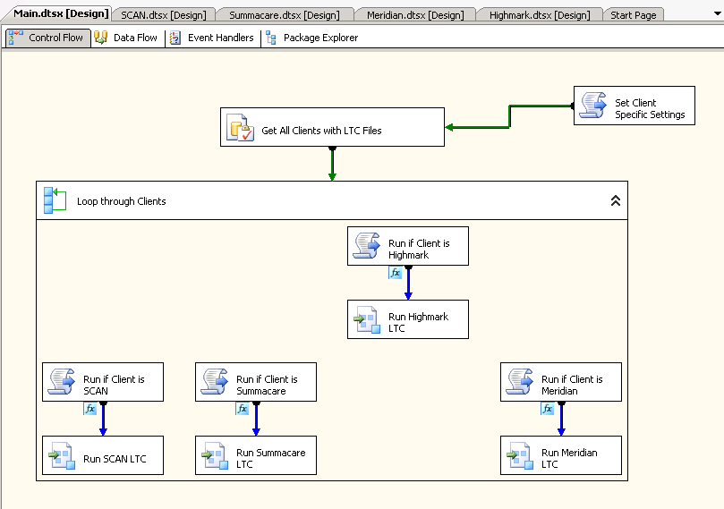

**Figure 1.** Main Package – Retrieve all clients marked as “LTC” from the ETLAutomation.dbo.ClientParameters table

Based on what PMDClientID/ClientID is returned from the config table, a particular package set is called.

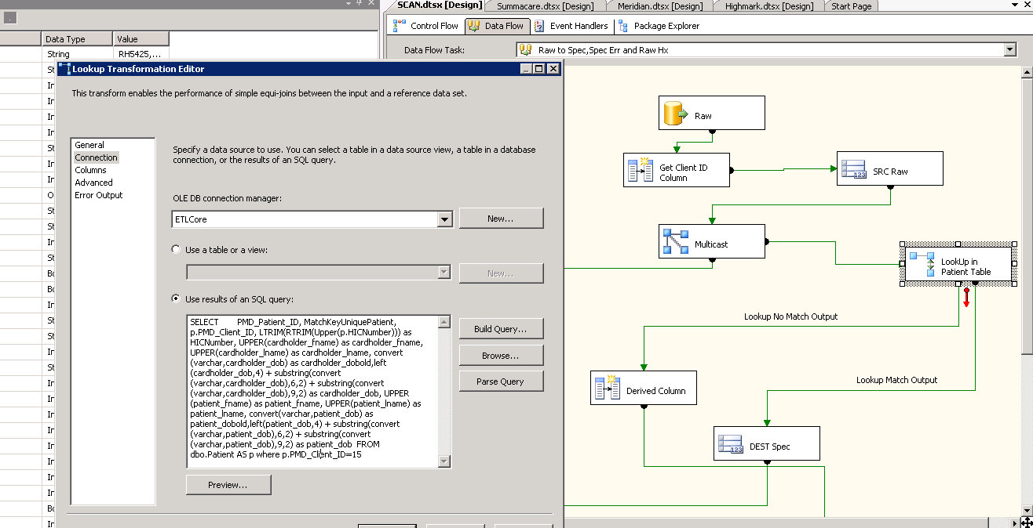

**Figure 2.** PMDClientID specific Lookup in Spec stage

The LTC data for MOST clients just goes into the CallListPatientsControl table on SQLOPS and a separate Call List Is created for outreach. However, for Highmark, we run a much fuller process where we generate PDF files and fax them to providers (this is mostly automated except for the actual fax transmission – Q3 2018).

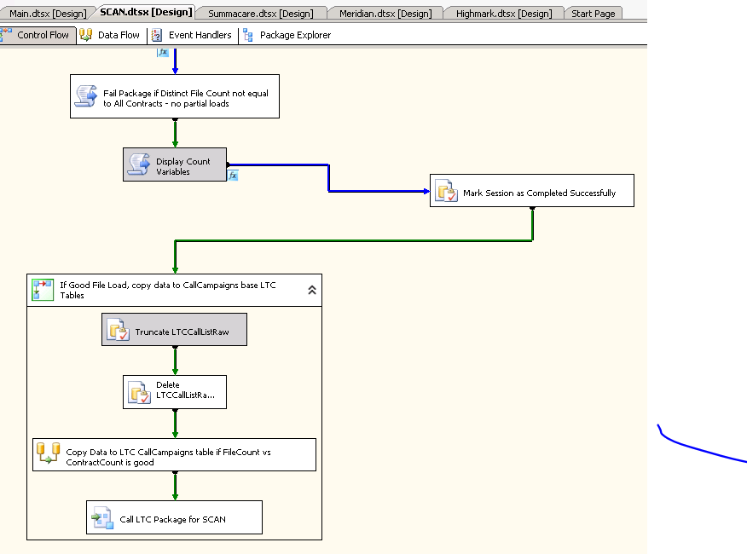

**Figure 3.** Individual Client LTC Package example